September 8, 2025 7pm
Park Committee Meeting
Staff Meeting
Joe, Jeremy, Jeff, Riley
Chris Clem arrived 7:18pm
Chris Williams – Elevantage Consulting
Lane Monson – JLM Development
Amy Coleman is absent - Jeff Davis taking minutes and Joe recording the meeting for Amy
Craig Jackson -Linc Construction
- Craig Jackson -Linx Construction – Pat Burns Development Vaquero / Longhorn – Meibos piece and other location further east – want to provide a park with built out pond and baseball fields, 14 acres . . . water shares. Spoke about the development agreement – they would like a letter indicating that we are tentatively agreed – Jeff indicated that we would like an updated agreement with plans of the developments, number of lots, description and size of park, water shares, and acknowledging a timeline will be included then Joe can get them a letter. Joe would like us to get bids for work done on the park to show transparency with the public.
- Howard Property - Chris Williams – Elevantage Consulting, Lane Monson – JLM Development – Proposing a water kayak park and regional open space and trails along with Black Pine park can we maintain that large of a regional park. Joe is going to talk to Charlie Ewert with Weber County Planning to discuss how this works within the county master plan. See plans – we can provide a letter about our potential agreement once we understand how this could be meaningful open space after a conversation with Charlie. We also need to evaluate how we would pay to maintain so much open space and maintain any trails that may be initially put in. Maybe continued natural landscape and trails combined with the black pine park property with a partnership with USU or Ogden Nature Center, or other organizations. Action Items: 1. Joe to meet with Charlie 2. Committee to discuss direction at October meeting 3. Meet again with developer at November meeting.

- 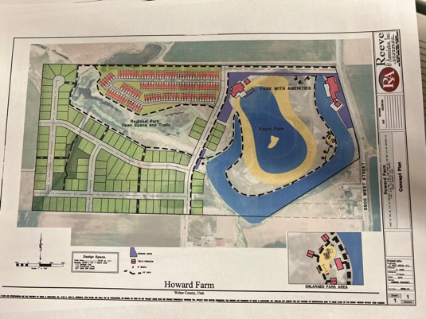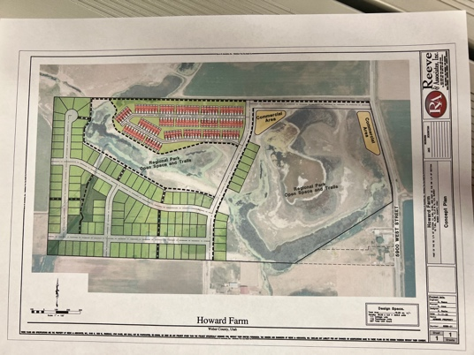

Board Meeting
- Approve meeting minutes joe move, riley second, approved by all
- Sign Checks
- Added check for McKenzie Clem for bathroom paper towels and soap
- Added check to Stone for maintenance work
- $1,000 for mosquito days – need receipts
- $300 for porta-potties in addition to $1,000 check to canyon view signed today
- Motion to adjourn Chris, 2nd Jeremy – all approved

